**TSMEAC**

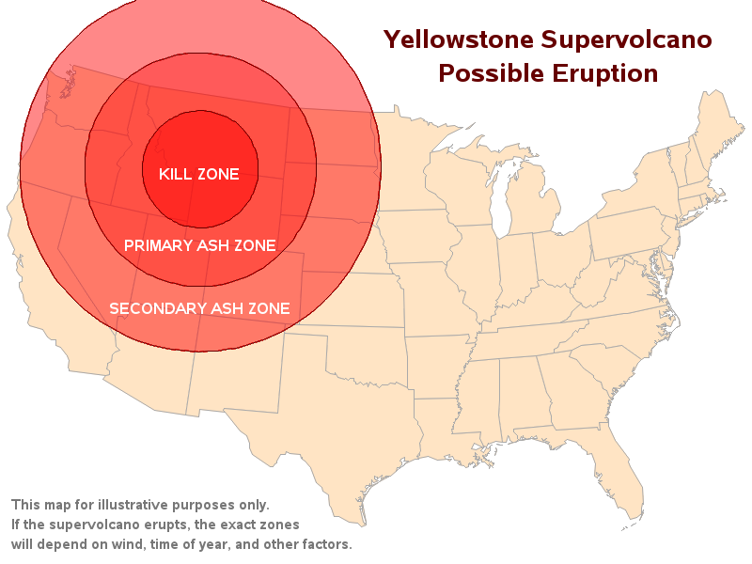TSMEAC can be used as a checklist that enables you to cover all factors when constructing and operational plan in the pre-operational phase. .

The TSMEAC checklist is as follows:  
https://nationalvetcontent.edu.au/alfresco/d/d/workspace/SpacesStore/5c5eee60-6101-497d-8e13-e1788d965f41/502/images/bullet.gif Topography (Layout of the land)  
https://nationalvetcontent.edu.au/alfresco/d/d/workspace/SpacesStore/5c5eee60-6101-497d-8e13-e1788d965f41/502/images/bullet.gif Site layout. *(Map of the area)*  
https://nationalvetcontent.edu.au/alfresco/d/d/workspace/SpacesStore/5c5eee60-6101-497d-8e13-e1788d965f41/502/images/bullet.gif Routes in and out. *(Plane, Boat, Air)*  
https://nationalvetcontent.edu.au/alfresco/d/d/workspace/SpacesStore/5c5eee60-6101-497d-8e13-e1788d965f41/502/images/bullet.gif Alternate routes. *(Roads, Trains)*  
https://nationalvetcontent.edu.au/alfresco/d/d/workspace/SpacesStore/5c5eee60-6101-497d-8e13-e1788d965f41/502/images/bullet.gif Area familiarisation. *(Information about the park, nearest hospital , airport)*  
https://nationalvetcontent.edu.au/alfresco/d/d/workspace/SpacesStore/5c5eee60-6101-497d-8e13-e1788d965f41/502/images/bullet.gif Site evacuation plan. *(Is there on in place, are there safety points)*

**Situation**   
https://nationalvetcontent.edu.au/alfresco/d/d/workspace/SpacesStore/5c5eee60-6101-497d-8e13-e1788d965f41/502/images/bullet.gif Establish the general outline of the operation.   
https://nationalvetcontent.edu.au/alfresco/d/d/workspace/SpacesStore/5c5eee60-6101-497d-8e13-e1788d965f41/502/images/bullet.gif Check the background to the assignment.    
https://nationalvetcontent.edu.au/alfresco/d/d/workspace/SpacesStore/5c5eee60-6101-497d-8e13-e1788d965f41/502/images/bullet.gif Special requirements determined (Women, children, the elderly, the ill, the sick, and the nearest hospital)

https://nationalvetcontent.edu.au/alfresco/d/d/workspace/SpacesStore/5c5eee60-6101-497d-8e13-e1788d965f41/502/images/bullet.gif Carry out threat and risk assessment. (Will people die carrying out your mission?)  
https://nationalvetcontent.edu.au/alfresco/d/d/workspace/SpacesStore/5c5eee60-6101-497d-8e13-e1788d965f41/502/images/bullet.gif Other agencies involved identified. (Australian Army, Red Cross, etc.)

**Mission**   
Short, concise and accurate statement that clearly explains the overall objective of the operation. This helps to guide the development of the operational plan.

*Example:* Our mission to locate the personal at Yellowstone and safely evacuate them.

**Execution**  
The actual plan for the operation - what? Who? When? Where? How? What if? It must include a detailed and clear record of timings, tasks, personnel, locations, liaison duties, methods, and contingency plans (or 'actions on').

**Administration and logistics**   
https://nationalvetcontent.edu.au/alfresco/d/d/workspace/SpacesStore/5c5eee60-6101-497d-8e13-e1788d965f41/502/images/bullet.gif Identify and obtain equipment and resources for the assignment   
https://nationalvetcontent.edu.au/alfresco/d/d/workspace/SpacesStore/5c5eee60-6101-497d-8e13-e1788d965f41/502/images/bullet.gif Organise documentation for the issue and receipt of equipment, e.g. equipment registers, faulty equipment report forms.

**Command & Signals**  
https://nationalvetcontent.edu.au/alfresco/d/d/workspace/SpacesStore/5c5eee60-6101-497d-8e13-e1788d965f41/502/images/bullet.gif Command is the hierarchy of staff - identify team leader(s), supervisor/s, liaison officer(s) etc.   
https://nationalvetcontent.edu.au/alfresco/d/d/workspace/SpacesStore/5c5eee60-6101-497d-8e13-e1788d965f41/502/images/bullet.gif Determine needs for communication equipment, covert or overt.   
https://nationalvetcontent.edu.au/alfresco/d/d/workspace/SpacesStore/5c5eee60-6101-497d-8e13-e1788d965f41/502/images/bullet.gif Identify alternate frequencies and communicate to staff.   
https://nationalvetcontent.edu.au/alfresco/d/d/workspace/SpacesStore/5c5eee60-6101-497d-8e13-e1788d965f41/502/images/bullet.gif Alternate means of communication identified (e.g. mobile phones) and back-up strategies communicated to staff.   
https://nationalvetcontent.edu.au/alfresco/d/d/workspace/SpacesStore/5c5eee60-6101-497d-8e13-e1788d965f41/502/images/bullet.gif Obtain and record contact numbers of other agencies involved, e.g. police, other security agencies and the VIP liaison officer. (Make up these numbers)  
https://nationalvetcontent.edu.au/alfresco/d/d/workspace/SpacesStore/5c5eee60-6101-497d-8e13-e1788d965f41/502/images/bullet.gif Prepare codes to be used and communicate these to the escort officers.   
https://nationalvetcontent.edu.au/alfresco/d/d/workspace/SpacesStore/5c5eee60-6101-497d-8e13-e1788d965f41/502/images/bullet.gif Establish hand signals to be used by the escorting officers if necessary.

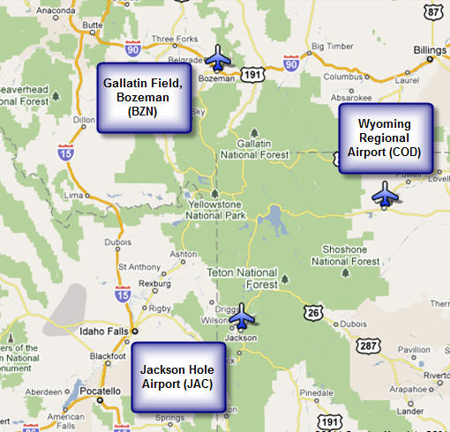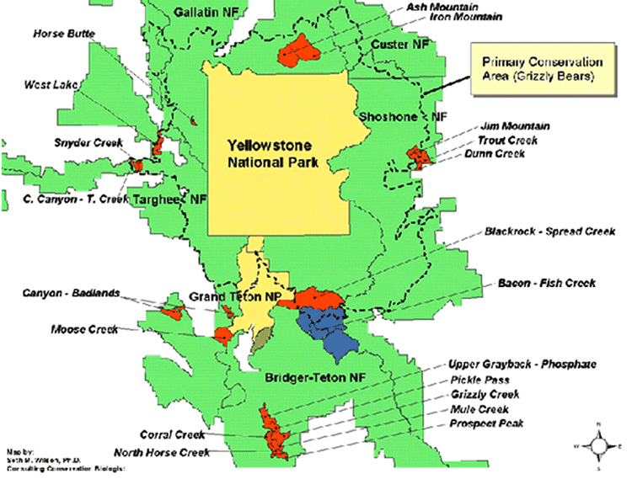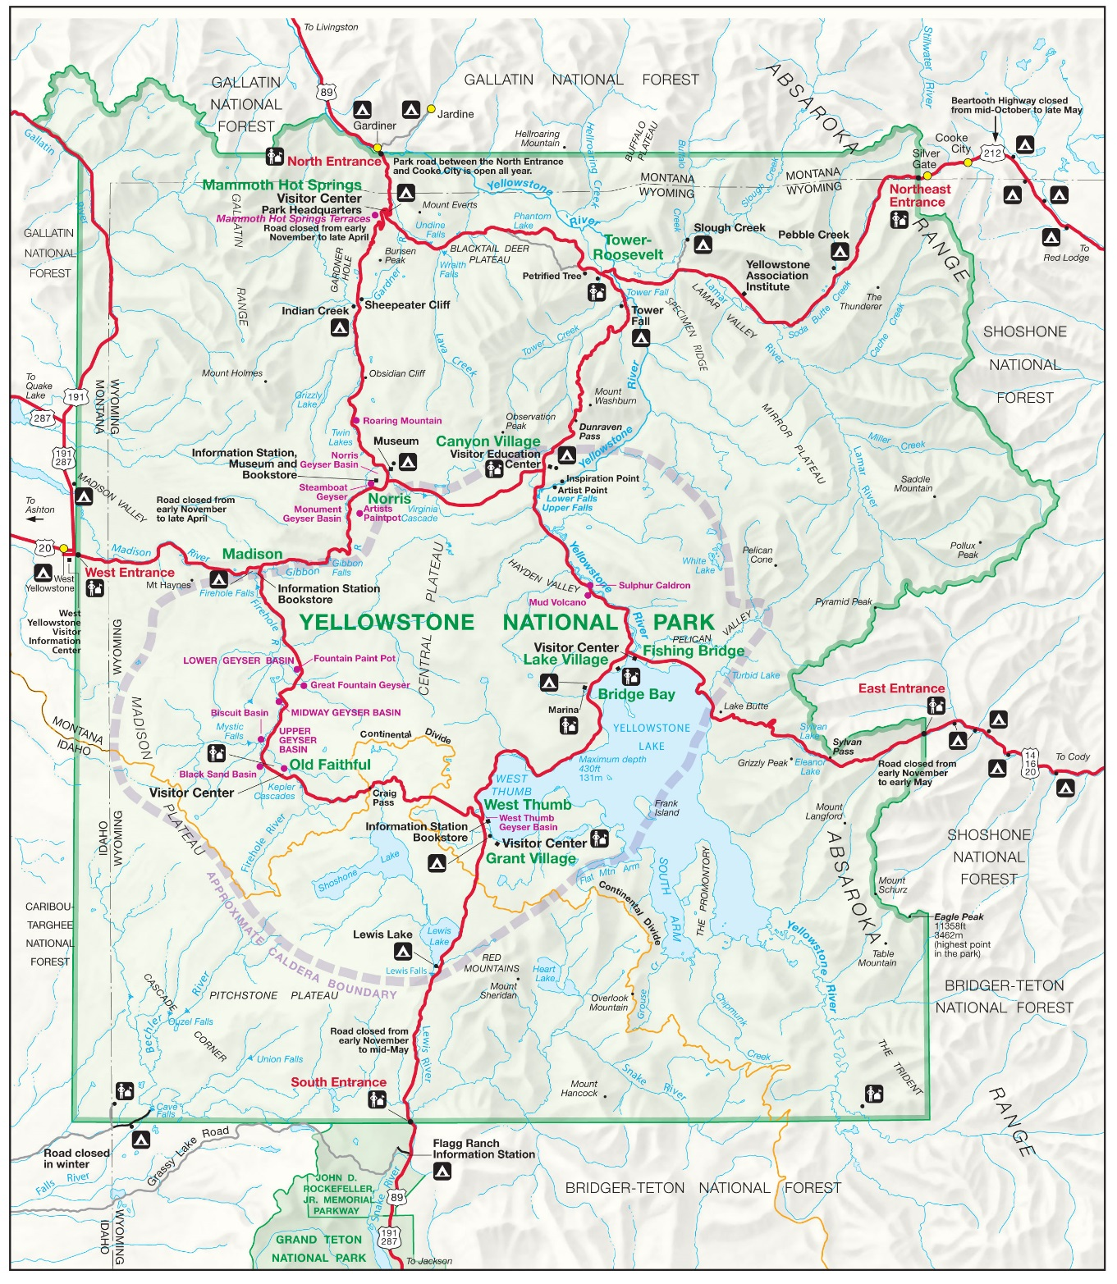

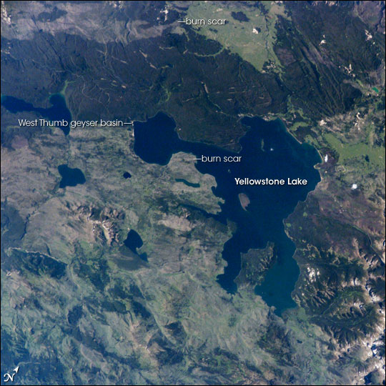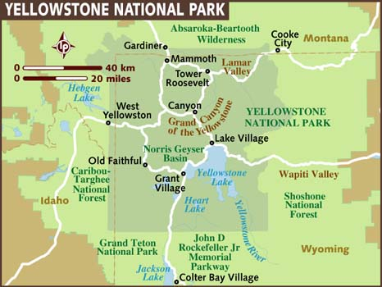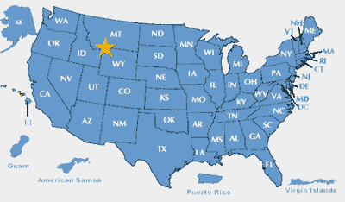

Emergency medical services are provided by rangers on duty.**Call 911 in case of an emergency.**

Medical services are available year round, except some holidays, at Mammoth Clinic (307 344-7965). Services are also offered seasonally in the summer at Lake Clinic (307 242-7241) and at Old Faithful Clinic (307 545-7325).

All of these clinics are open to the public and are staffed and equipped for most medical emergencies as well as for routine care. Services include injury and illness treatment, x-rays, and some lab and pharmacy services.

If in-patient care or advanced services are required, the clinic staff can stabilize patients and arrange for appropriate transfer to a hospital outside the park.